**CONSISTENT HASHING**

To achieve horizontal scaling, it is important to distribute requests/data efficiently and evenly across servers. Consistent hashing is a commonly used technique to achieve this goal. It plays a crucial role in various distributed systems and databases to ensure that when a hash table is resized (especially in a distributed environment), only a minimal number of keys need to be remapped.

**Scalability**

Consistent hashing makes it easier to scale a system horizontally. You can add or remove nodes without significantly affecting the overall system. In traditional hashing, adding or removing a bucket requires rehashing all keys, but with consistent hashing, only a fraction of the keys need to be remapped.

### Distributed Caching

It's particularly useful in distributed caching systems like memcached. Consistent hashing ensures that when a cache machine is added or removed, only a small portion of the keys are moved to different cache machines. This minimizes cache misses and distributes the load evenly.

### Load Balancing

Consistent hashing helps in distributing requests or data evenly across a cluster of servers. This is essential for load balancing in distributed systems, ensuring that no single node becomes a bottleneck.

**The rehashing problem**

If you have *n* cache servers, a common way to balance the load is to use the following hash method:

*serverIndex = hash(key) % N*, where *N* is the size of the server pool.

To fetch the server where a key is stored, we perform the modular operation *f(key) % 4*

For instance, *hash(key0) % 4 = 1* means a client must contact server 1 to fetch the cached data.

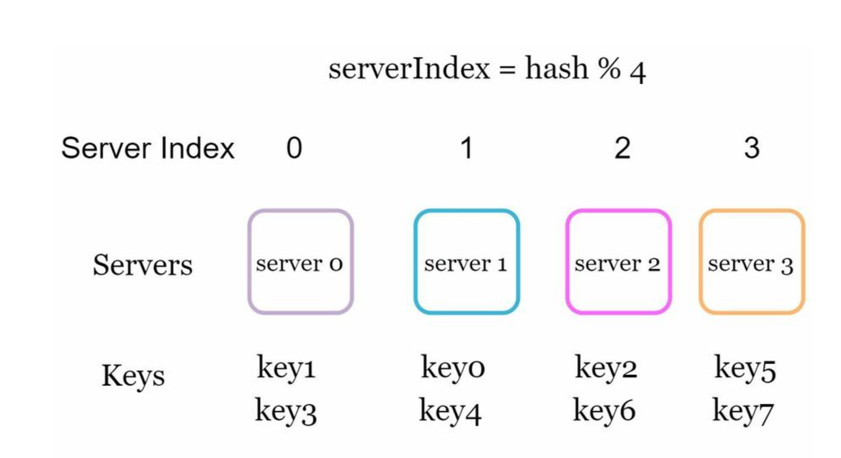

**This approach works well when the size of the server pool is fixed and the data distribution is even**

However, problems arise when new servers are added, or existing servers are removed.

For example, if server 1 goes offline, the size of the server pool becomes 3. Using the same hash function, we get the same hash value for a key. But applying modular operation gives us different server indexes because the number of servers is reduced by 1.

We get the results as shown

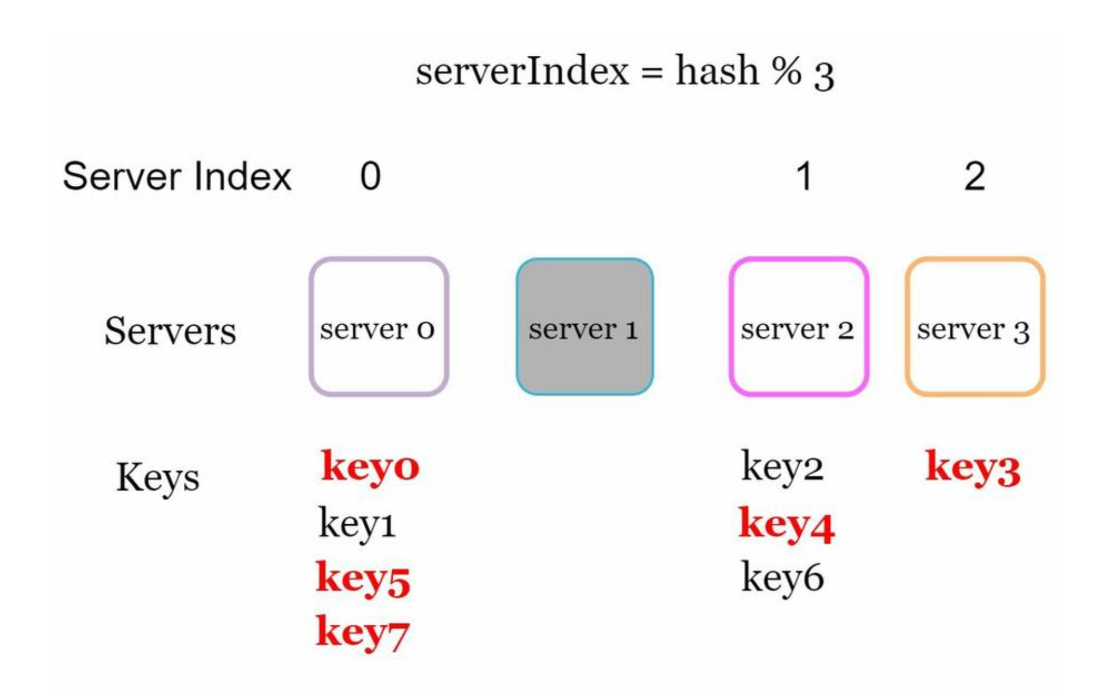

Most keys are redistributed, not just the ones originally stored in the offline server (server 1). This means that when server 1 goes offline, most cache clients will connect to the wrong servers to fetch data. This causes a storm of cache misses. Consistent hashing is an effective technique to mitigate this problem.

**Consistent hashing**

Quoted from Wikipedia: "Consistent hashing is a special kind of hashing such that when a hash table is re-sized and consistent hashing is used, only k/n keys need to be remapped on average, where k is the number of keys, and n is the number of slots. In contrast, in most traditional hash tables, a change in the number of array slots causes nearly all keys to be remapped [1]”.

**Hash space and hash ring**

Now we understand the definition of consistent hashing, let us find out how it works. Assume SHA-1 is used as the hash function f, and the output range of the hash function is: *x0, x1, x2, x3, ..., xn*. In cryptography, SHA-1’s hash space goes from 0 to 2^160 - 1. That means *x0* corresponds to 0, *xn* corresponds to 2^160 – 1, and all the other hash values in the middle fall between 0 and 2^160 - 1. Figure 5-3 shows the hash space.

By collecting both ends, we get a hash ring as shown

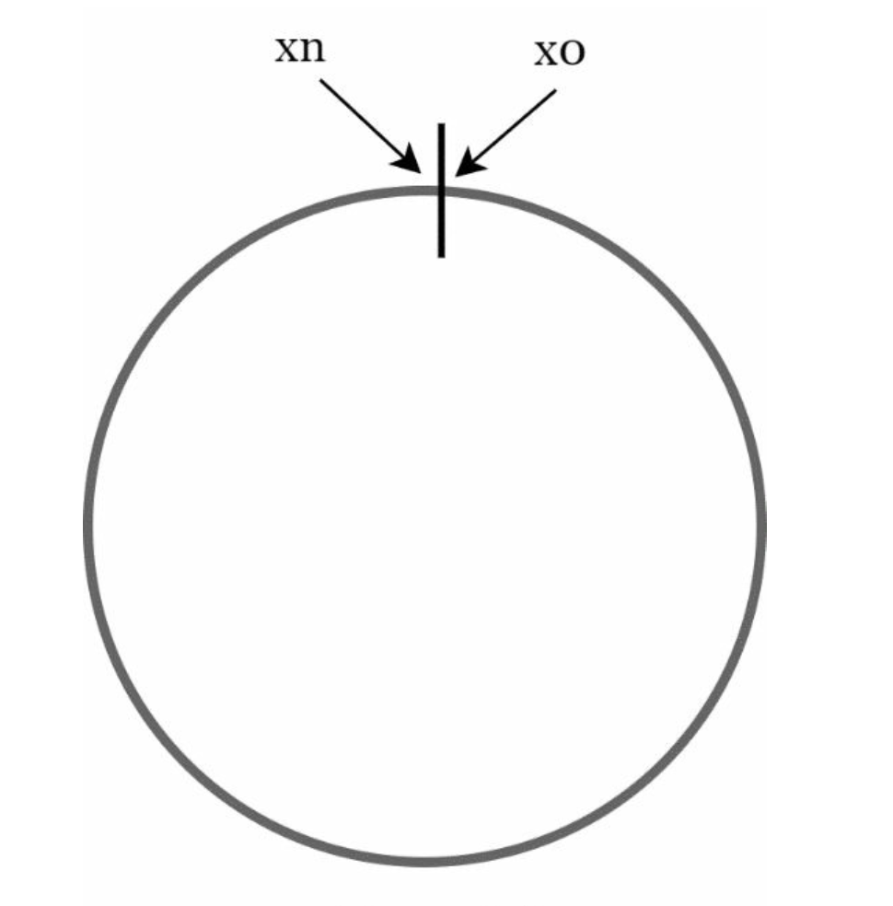

**Hash servers**

Using the same hash function f, we map servers based on server IP or name onto the ring.

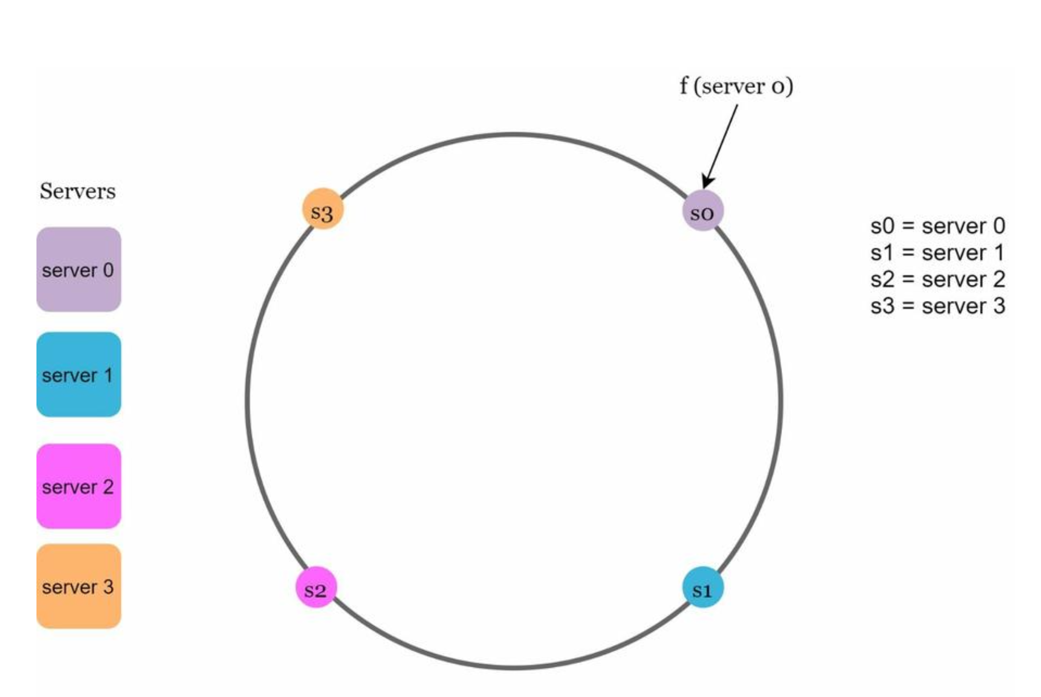

**Hash keys**

One thing worth mentioning is that hash function used here is different from the one in “the rehashing problem,” and there is no modular operation. As shown in Figure 5-6, 4 cache keys (key0, key1, key2, and key3) are hashed onto the hash ring

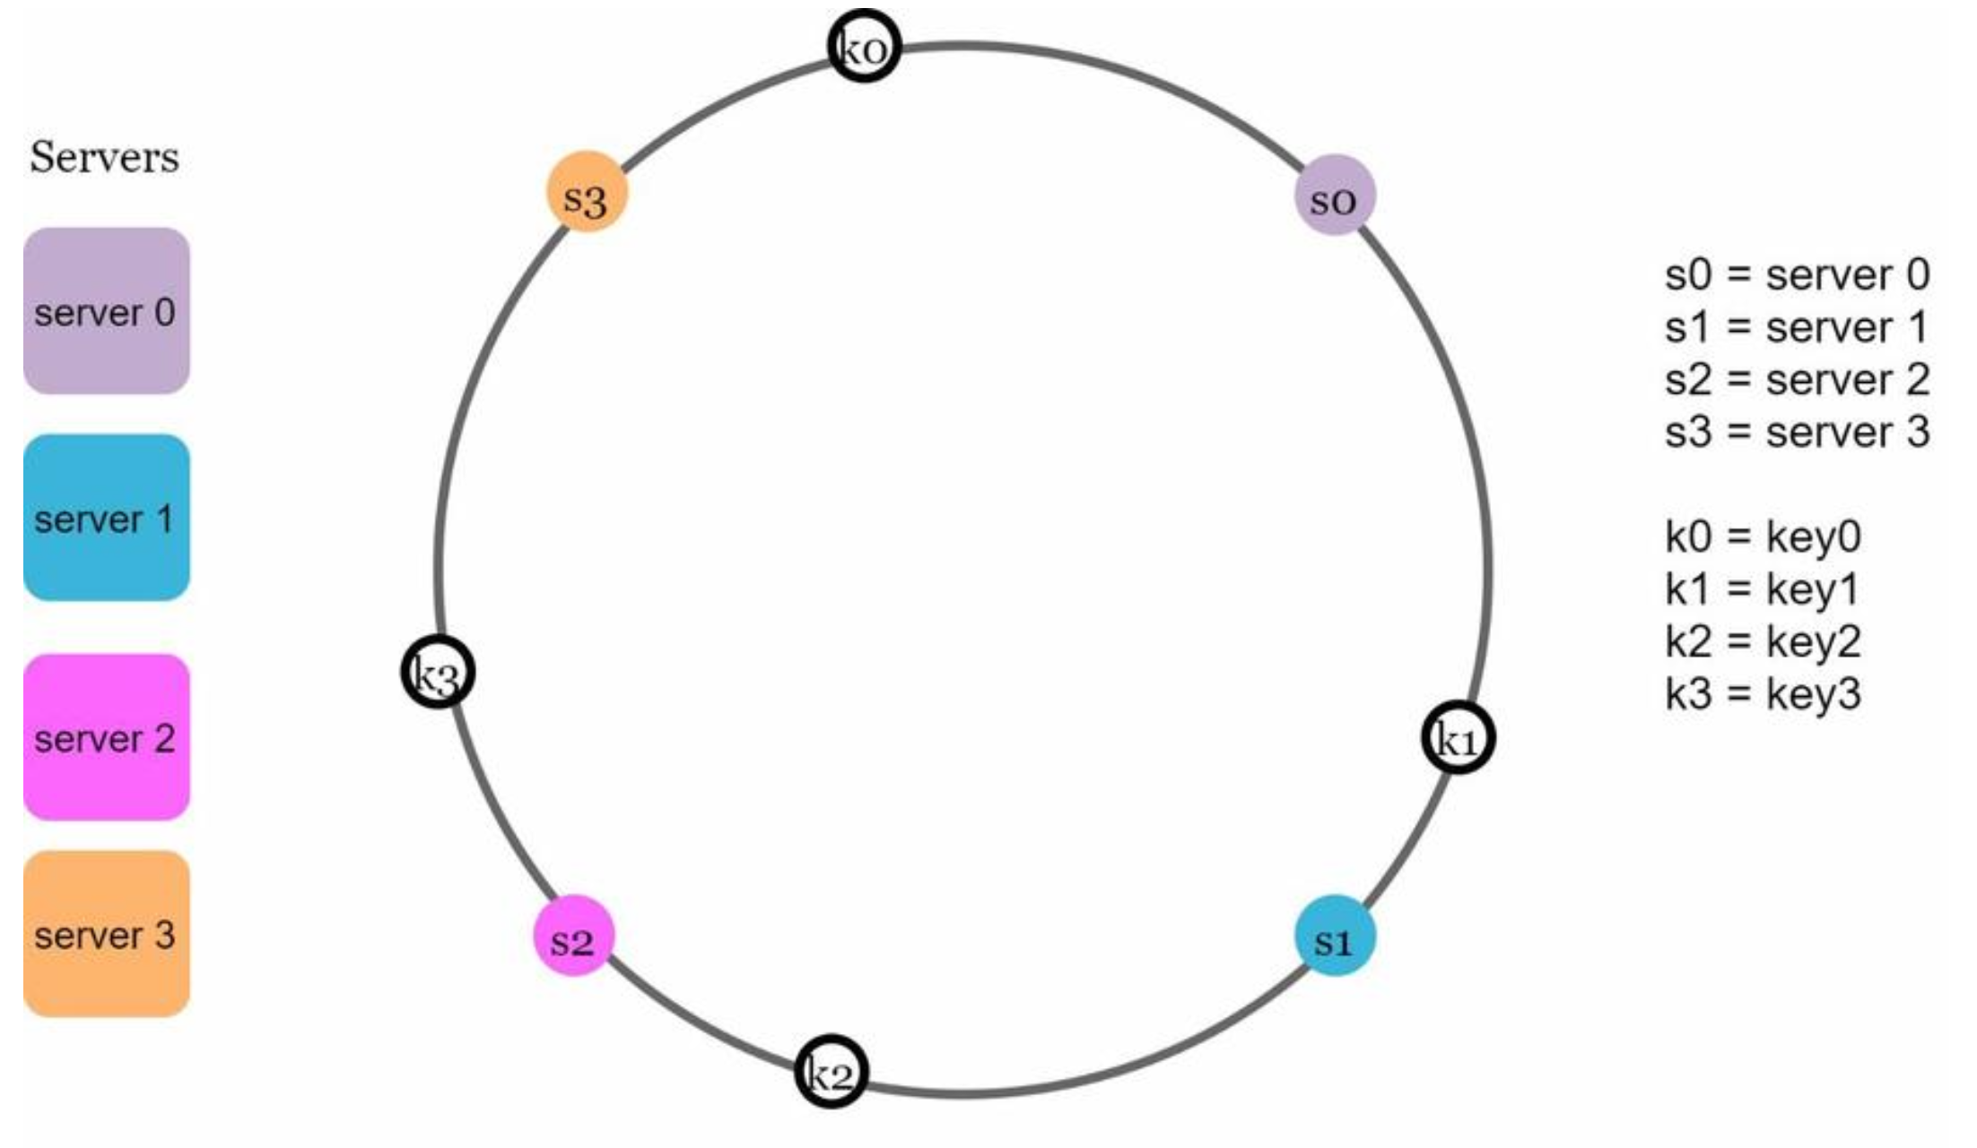

To determine which server a key is stored on, we go clockwise from the key position on the ring until a server is found.

Going clockwise, *key0* is stored on *server 0*; *key1* is stored on *server 1*; *key2* is stored on *server 2* and *key3* is stored on *server 3*.

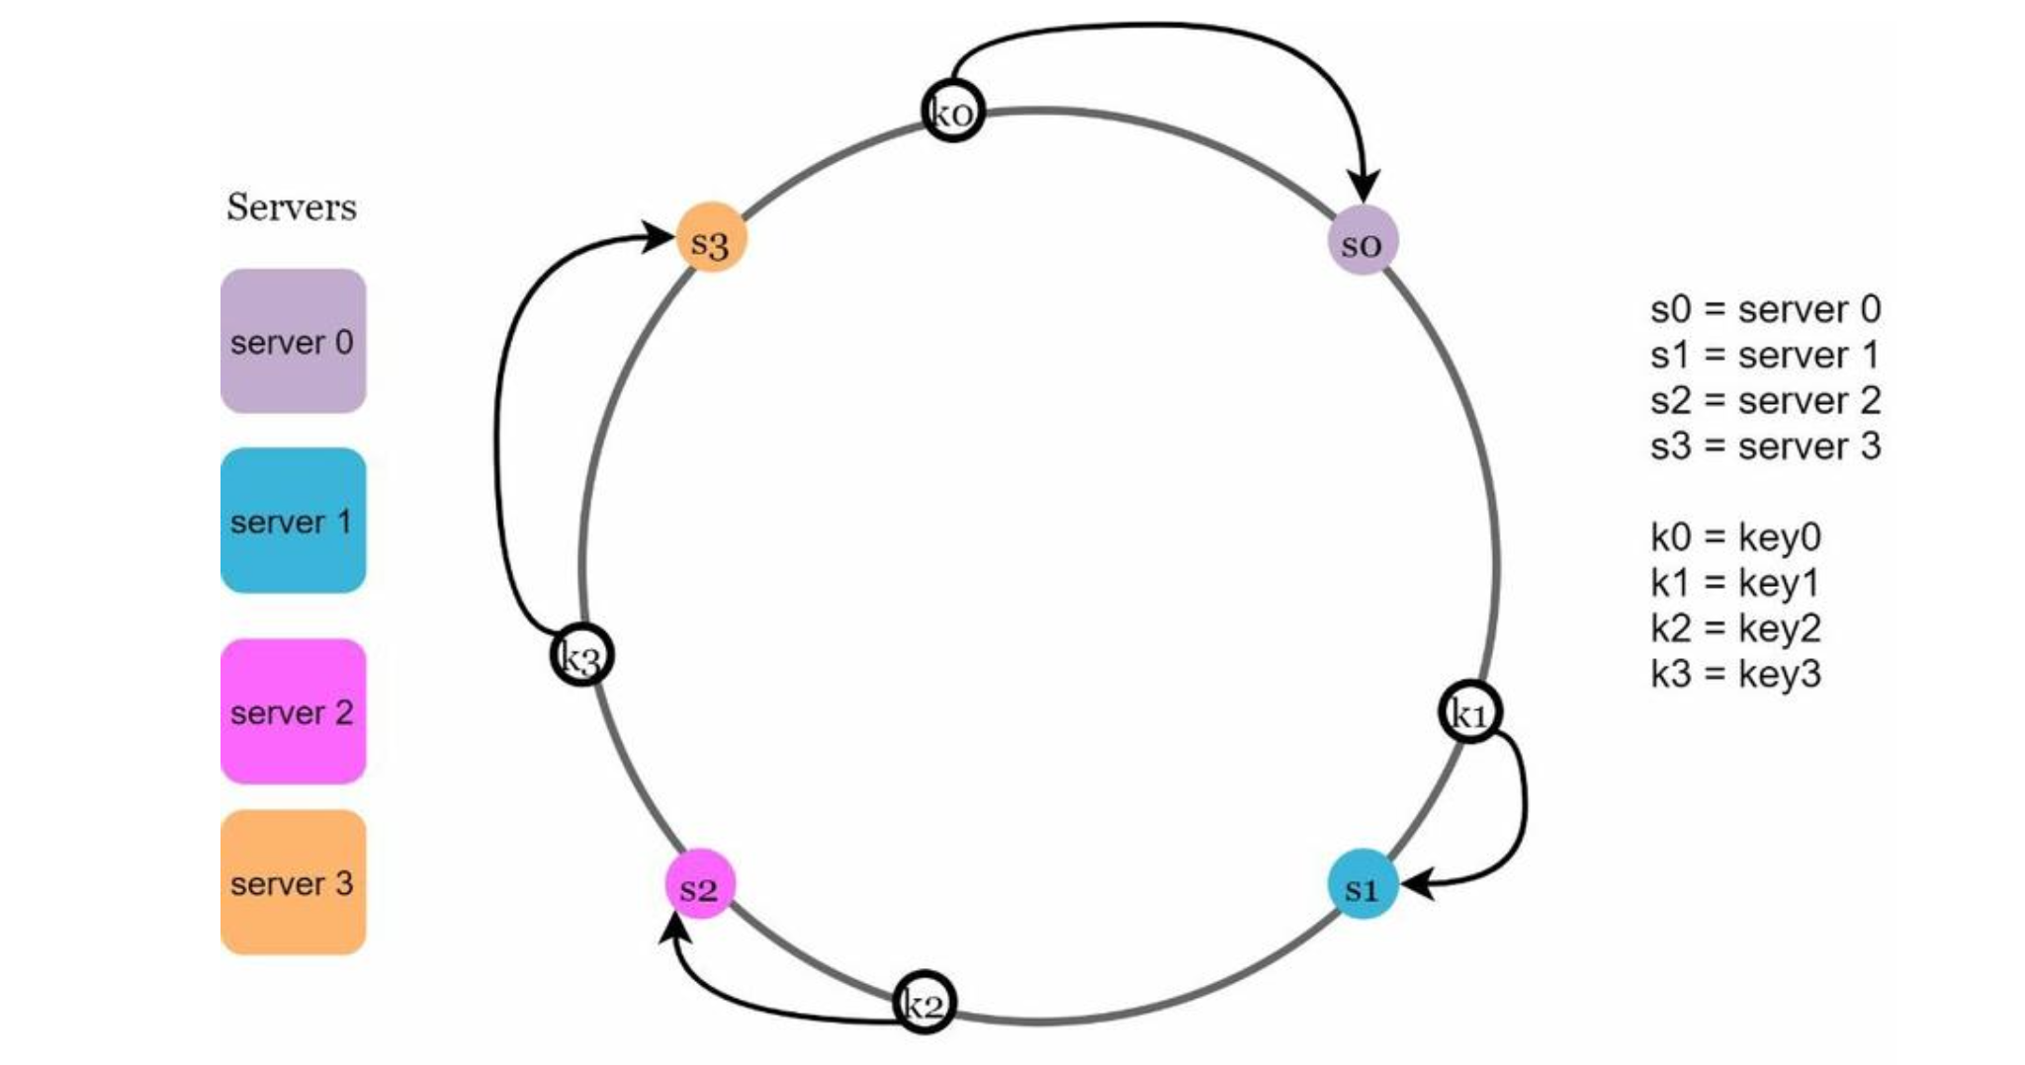

**Add a server**

Using the logic described above, adding a new server will only require redistribution of a fraction of keys.

after a new *server 4* is added, only *key0* needs to be redistributed. *k1, k2,* and *k3* remain on the same servers.

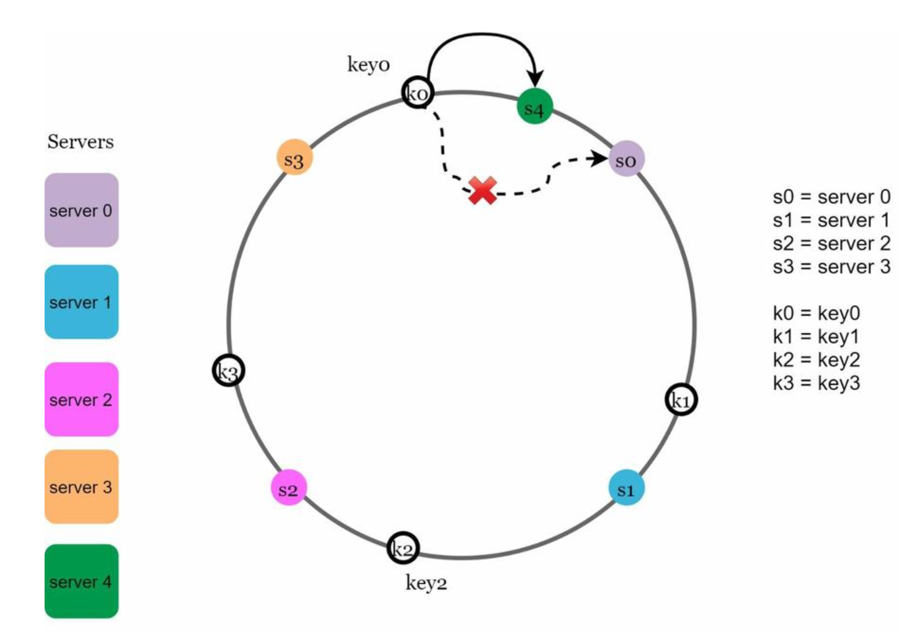

**Remove a server**

When a server is removed, only a small fraction of keys require redistribution with consistent hashing.

When *server 1* is removed, only *key1* must be remapped to *server 2*. The rest of the keys are unaffected.

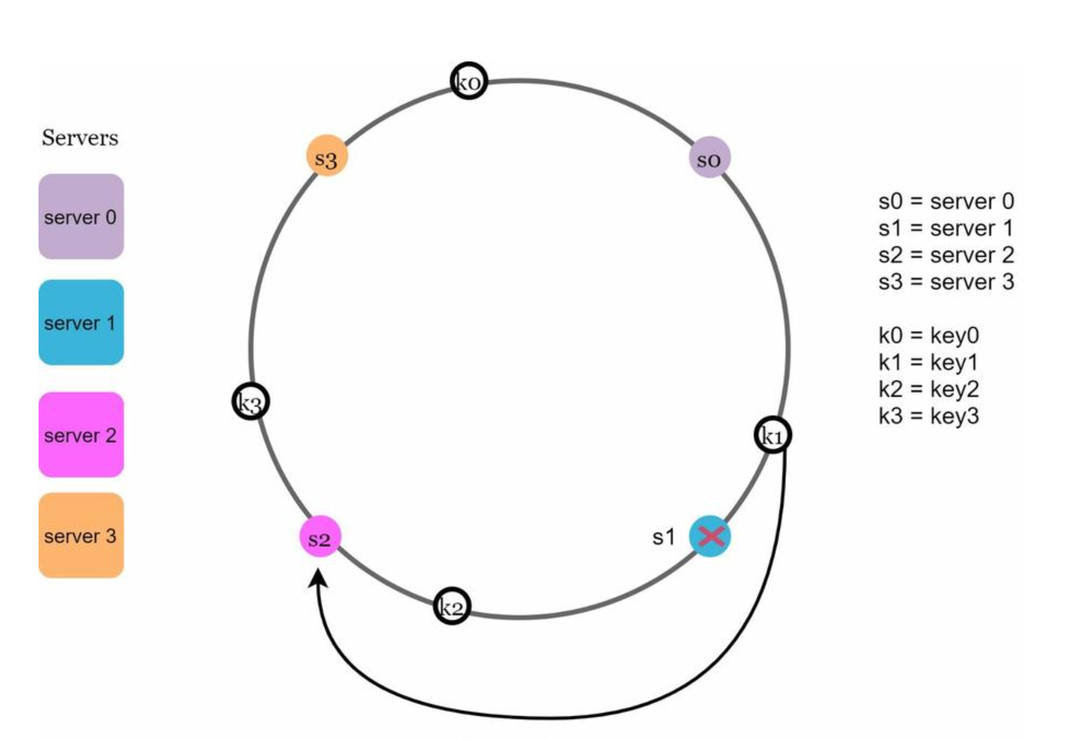

**Two issues in the basic approach**

The consistent hashing algorithm was introduced by Karger et al. at MIT [1]. The basic steps are:

• Map servers and keys on to the ring using a uniformly distributed hash function.

• To find out which server a key is mapped to, go clockwise from the key position until the first server on the ring is found.

Two problems are identified with this approach. First, it is impossible to keep the same size of partitions on the ring for all servers considering a server can be added or removed. A partition is the hash space between adjacent servers. It is possible that the size of the partitions on the ring assigned to each server is very small or fairly large.

if *s1* is removed, *s2’s* partition (highlighted with the bidirectional arrows) is twice as large as *s0* and *s3’s* partition.

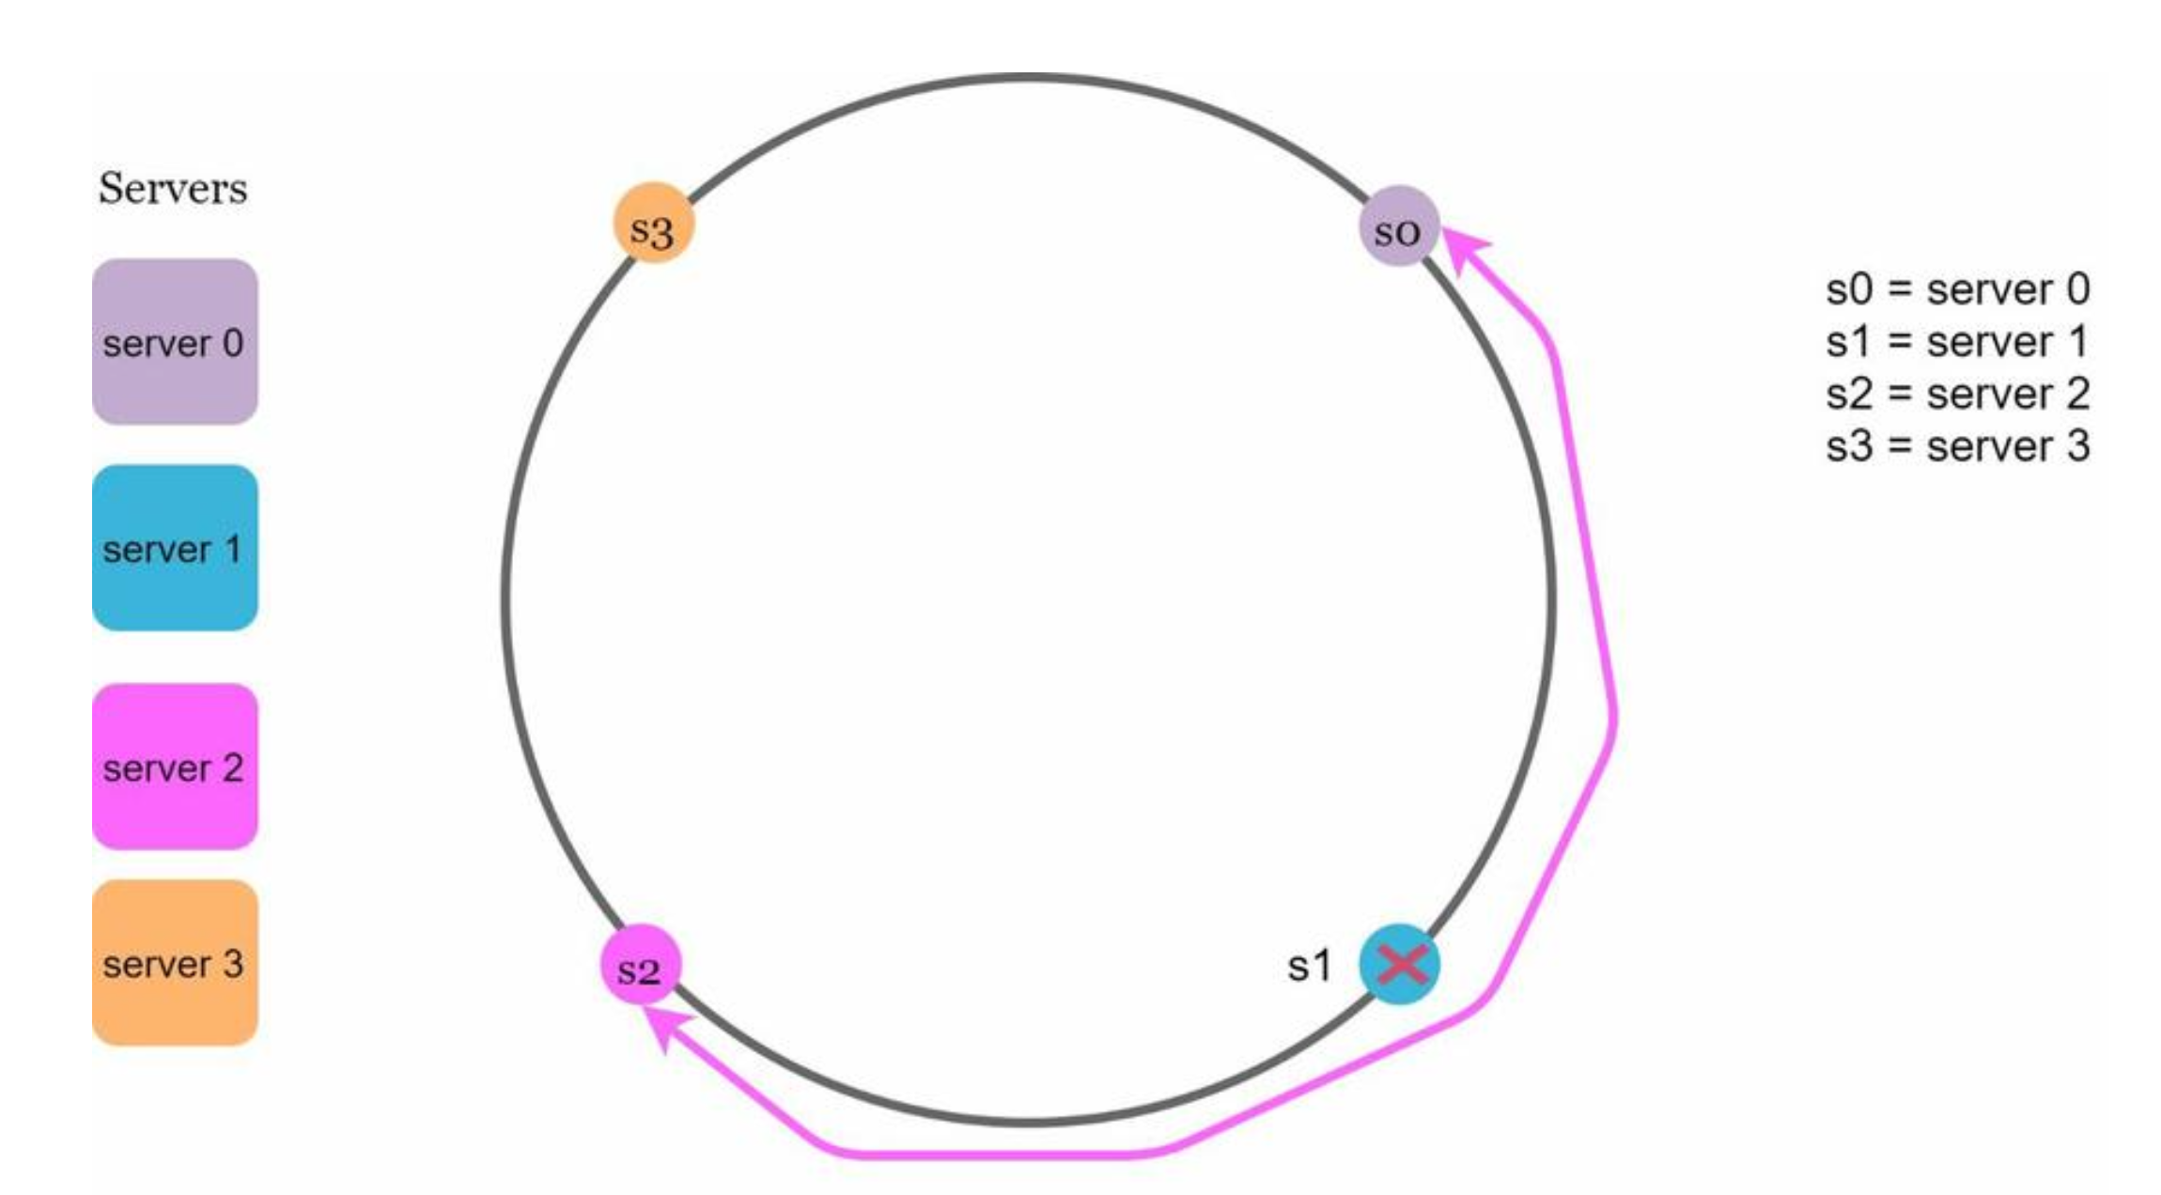

Second, it is possible to have a non-uniform key distribution on the ring. For instance, if servers are mapped to positions listed in Figure below, most of the keys are stored on *server 2*. However, *server 1* and *server 3* have no data.

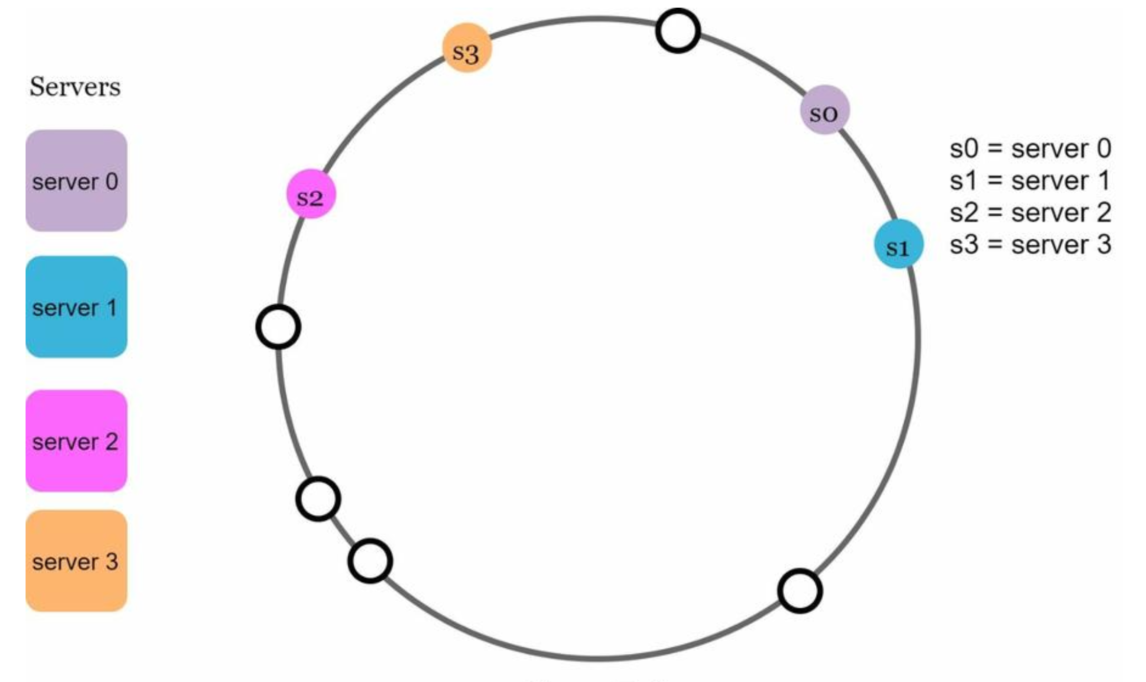

A technique called virtual nodes or replicas is used to solve these problems.

**Virtual nodes**

A virtual node refers to the real node, and each server is represented by multiple virtual nodes on the ring.

both *server 0* and *server 1* have 3 virtual nodes. The 3 is

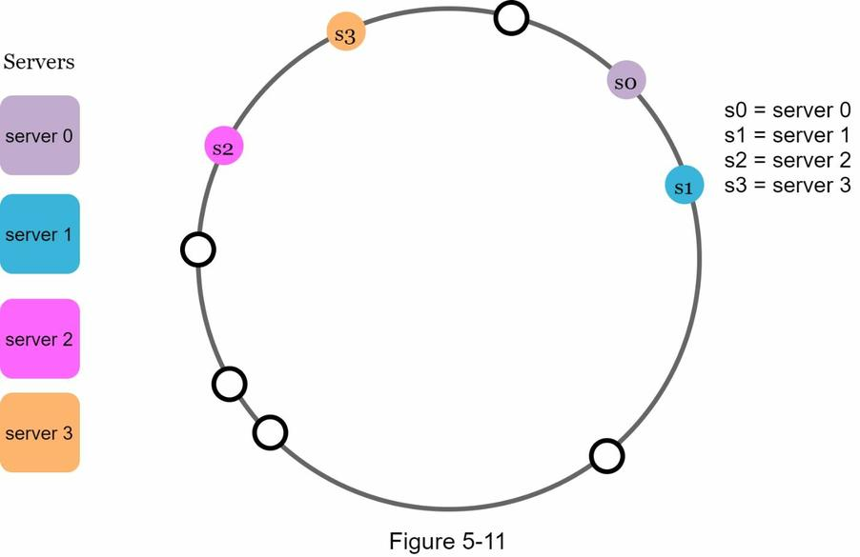

arbitrarily chosen; and in real-world systems, the number of virtual nodes is much larger. Instead of using *s0*, we have *s0_0, s0_1*, and s0_2 to represent *server 0* on the ring. Similarly, *s1_0, s1_1*, and *s1_2* represent server 1 on the ring. With virtual nodes, each server is responsible for multiple partitions. Partitions (edges) with label *s0* are managed by server 0. On the other hand, partitions with label *s1* are managed by *server 1*

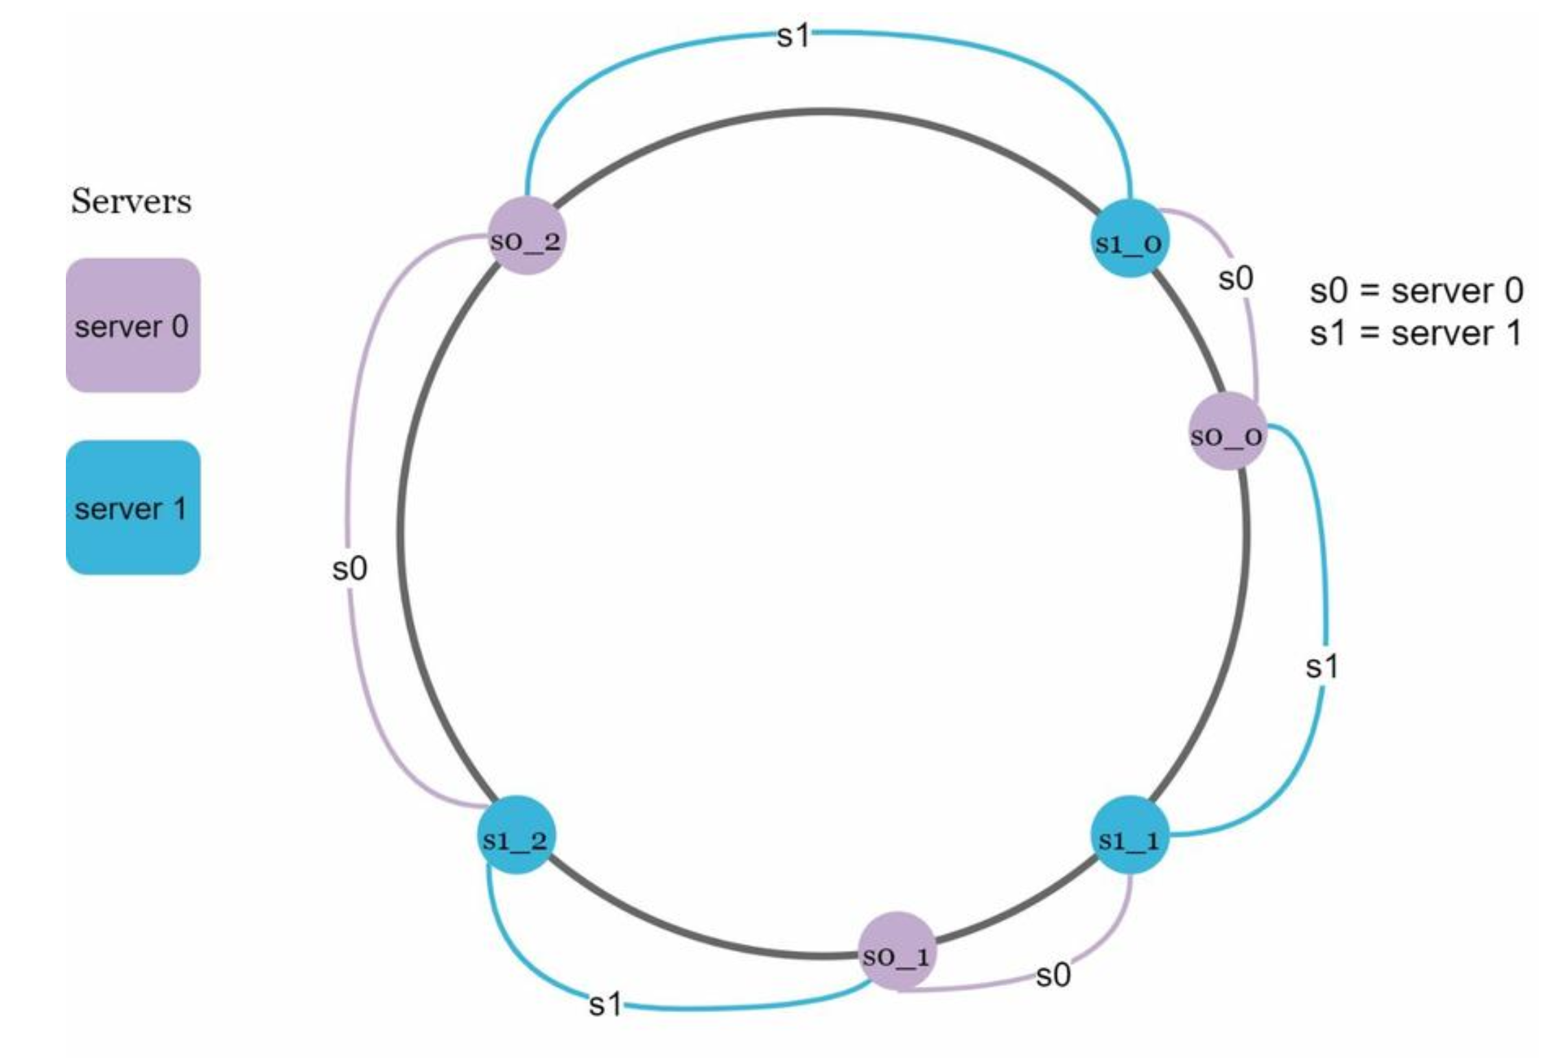

To find which server a key is stored on, we go clockwise from the key’s location and find the first virtual node encountered on the ring. In Figure below, to find out which server *k0* is stored on, we go clockwise from *k0*’s location and find virtual node *s1_1*, which refers to *server 1*.

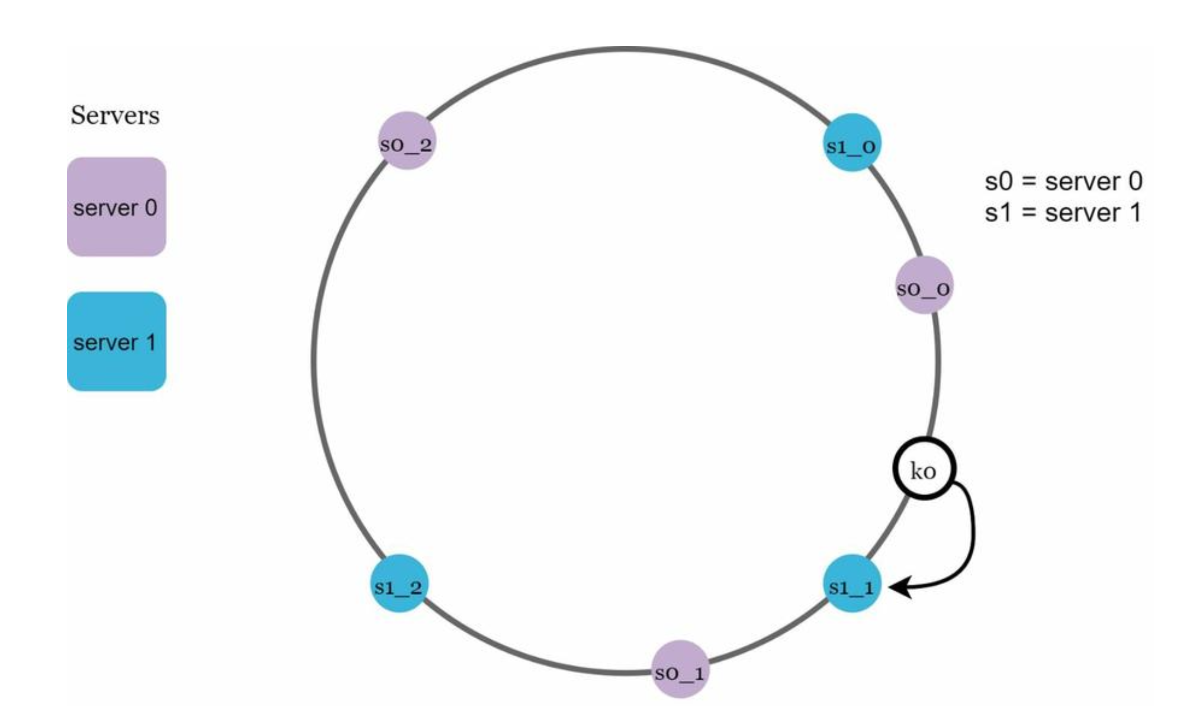

As the number of virtual nodes increases, the distribution of keys becomes more balanced. This is because the standard deviation gets smaller with more virtual nodes, leading to balanced data distribution. Standard deviation measures how data are spread out. The outcome of an experiment carried out by online research [2] shows that with one or two hundred virtual nodes, the standard deviation is between 5% (200 virtual nodes) and 10% (100 virtual nodes) of the mean. The standard deviation will be smaller when we increase the number of virtual nodes. However, more spaces are needed to store data about virtual nodes. This is a tradeoff, and we can tune the number of virtual nodes to fit our system requirements.

**Find affected keys**

When a server is added or removed, a fraction of data needs to be redistributed. How can we find the affected range to redistribute the keys?

*server 4* is added onto the ring. The affected range starts from *s4* (newly added node) and moves anticlockwise around the ring until a server is found (*s3*). Thus, keys located between *s3* and *s4* need to be redistributed to *s4*.

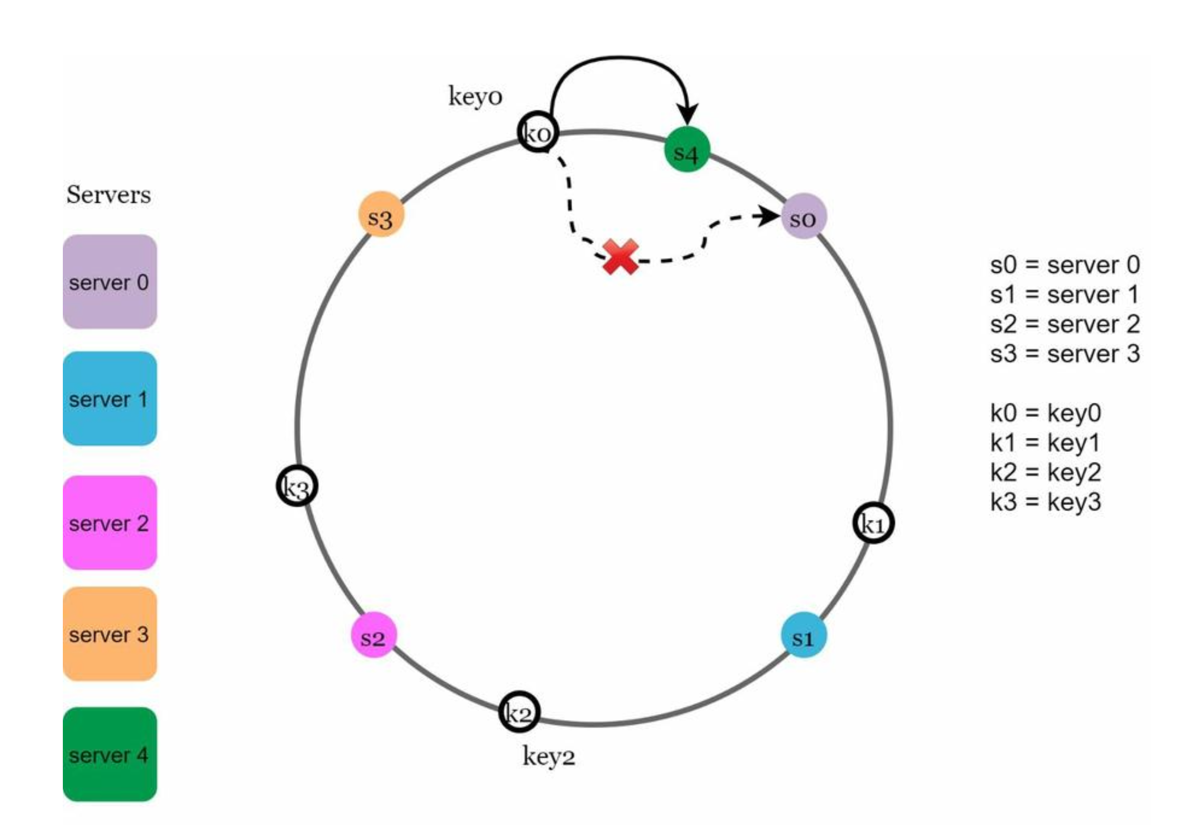

When a server (*s1*) is removed as shown in Figure below, the affected range starts from *s1* (removed node) and moves anticlockwise around the ring until a server is found (*s0*). Thus, keys located between *s0* and *s1* must be redistributed to *s2*.

